Assignment 1

* Creation of Amazon Route53 with Domain creation

(How to Configure Amazon Route 53?)

Steps to Create Amazon Route 53:

1. First to create an Ec2 linux server.

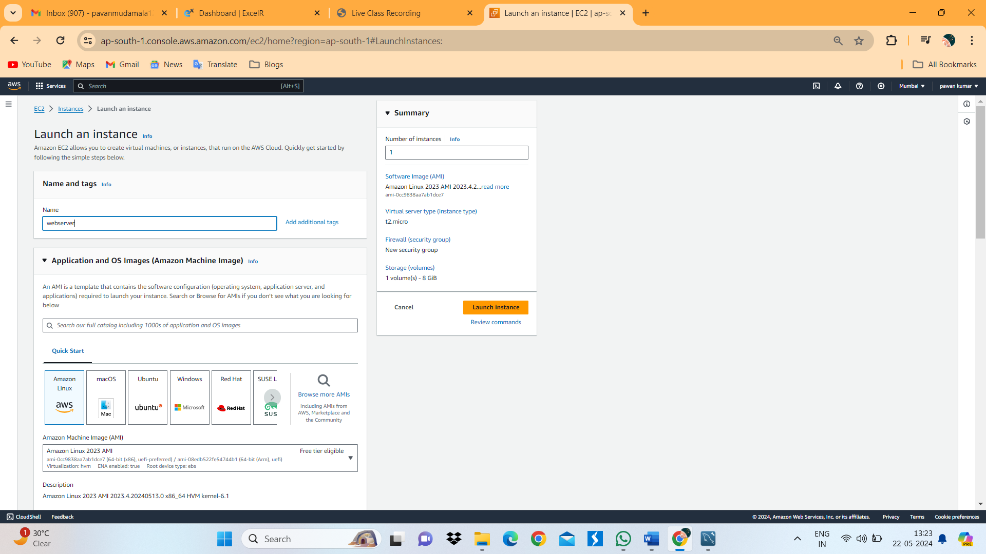

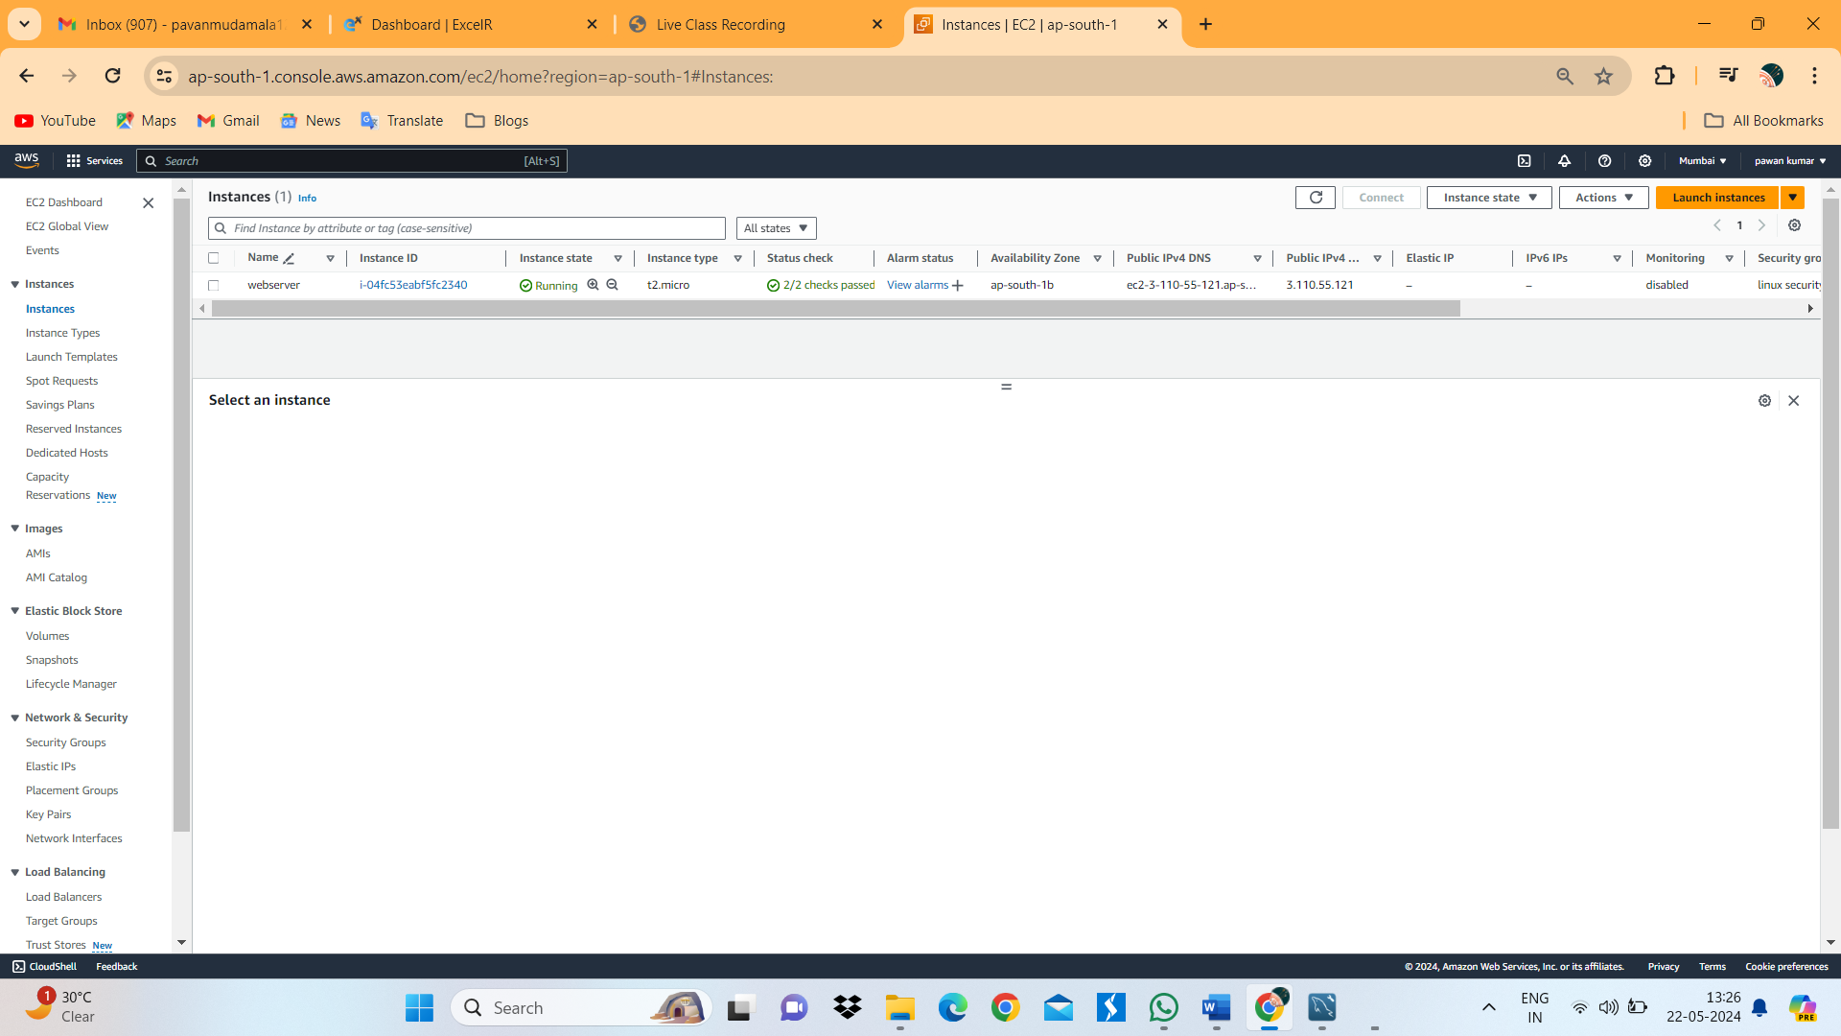

1. Above image shows the running condition of server.
2. Connect to server.

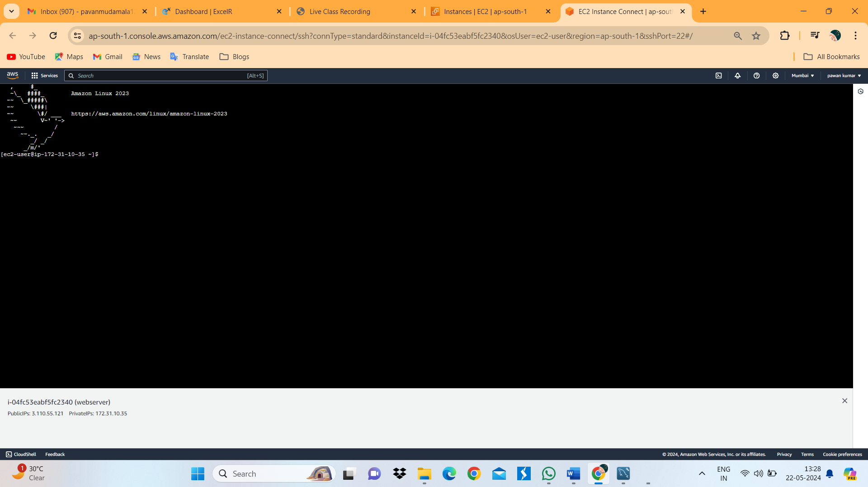

1. Install httpd in linuxserver.
2. In index.html write “This is sample website”. Which will appear in website.

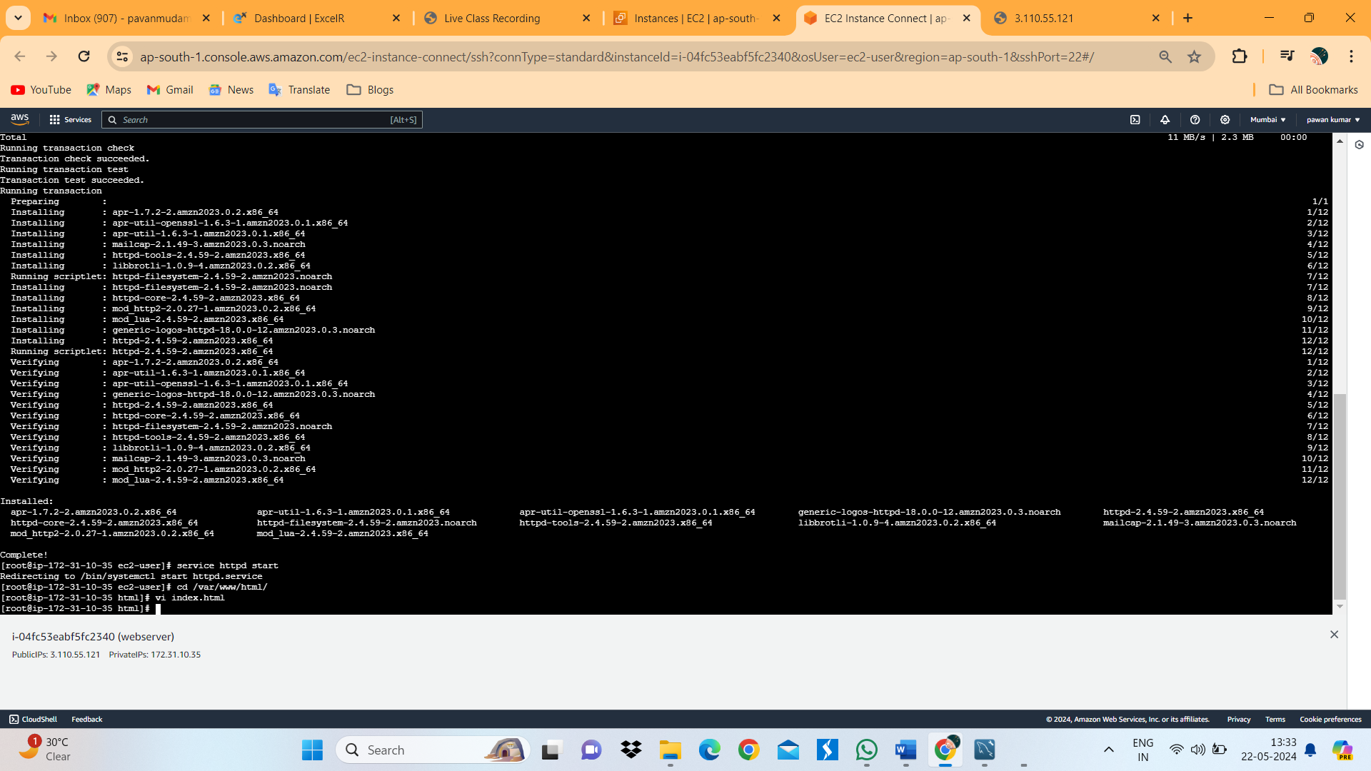

1. Checking the server is working or not by using Public ip address.

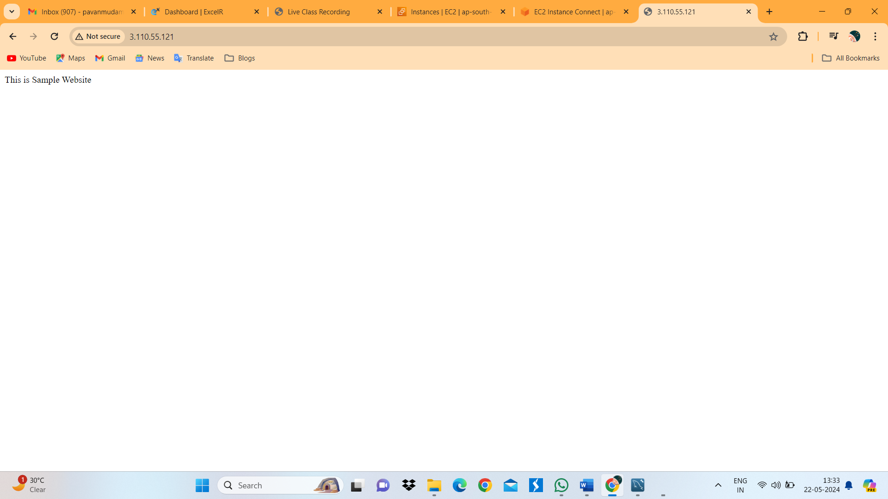

1. Open Route53 Dashboard. And click on Create hosted Zone.

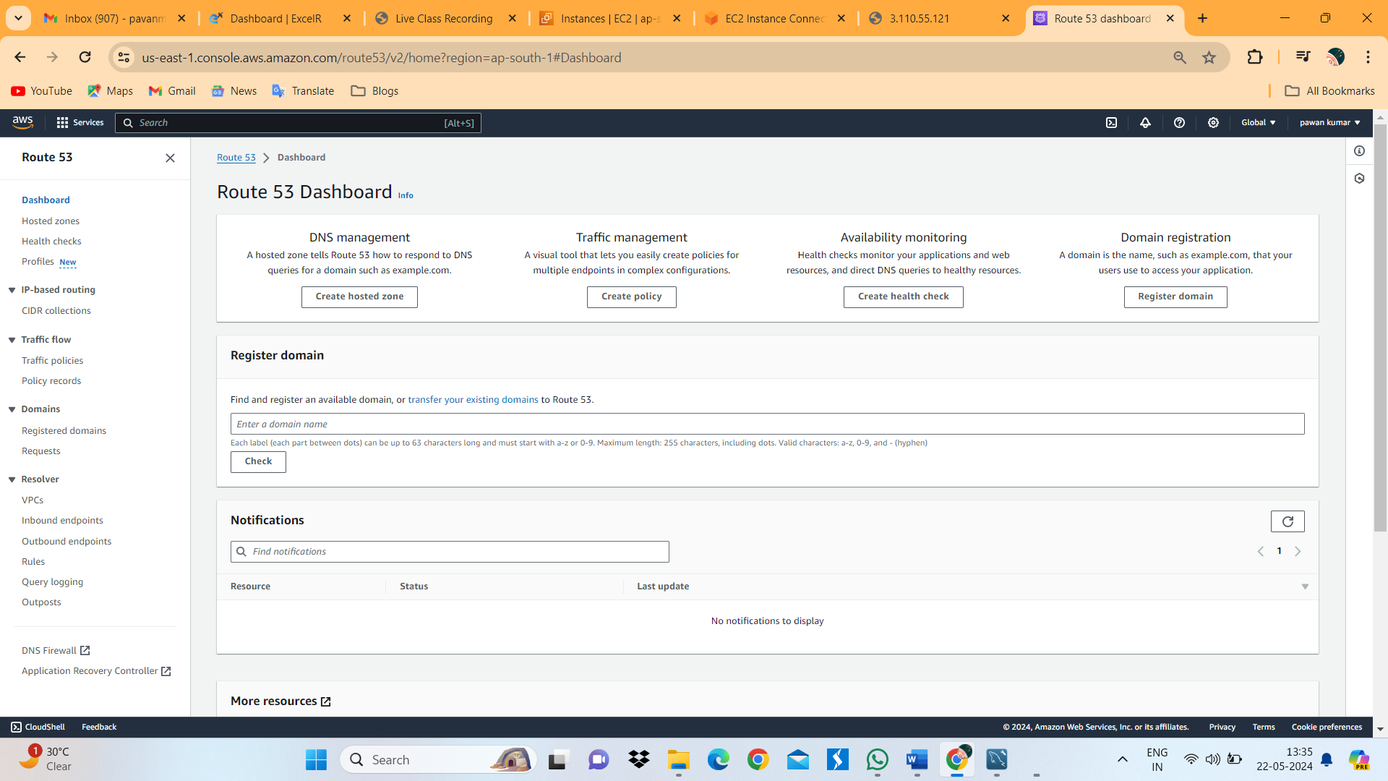

1. Give domain name and then click on create hosted zone.

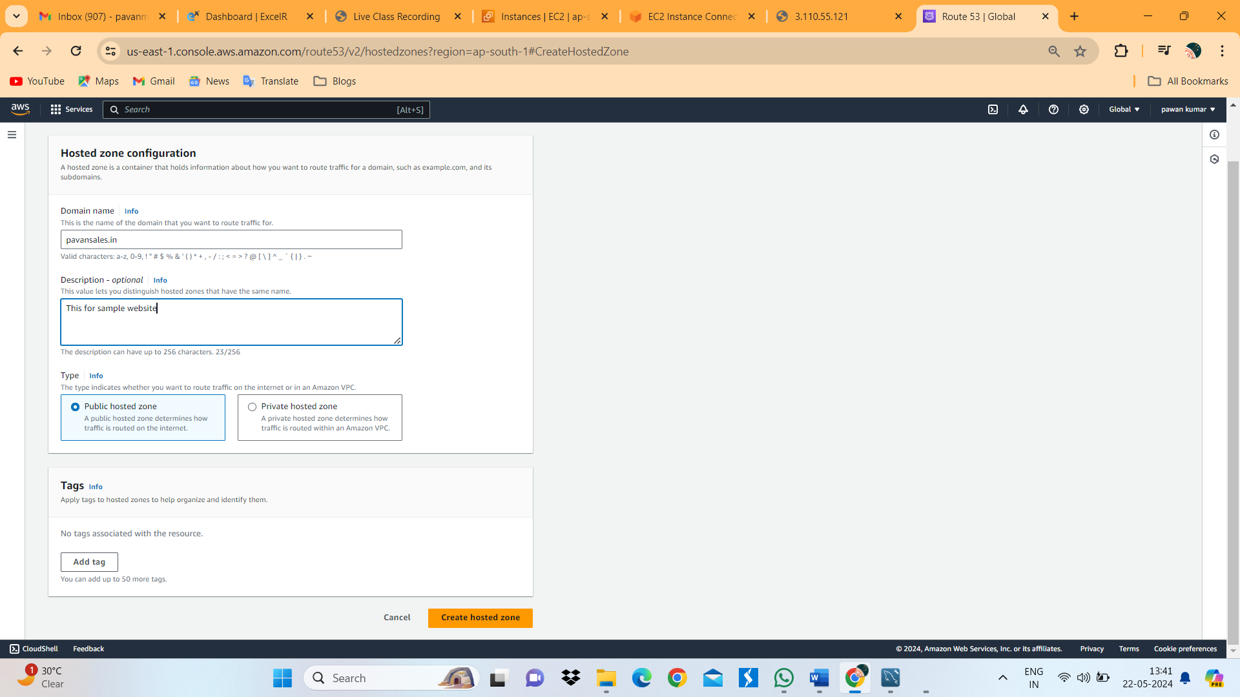

1. By Default AWS will create NS and SOA Services. So, we neeed to create “A” DNS. For that click on create Record.

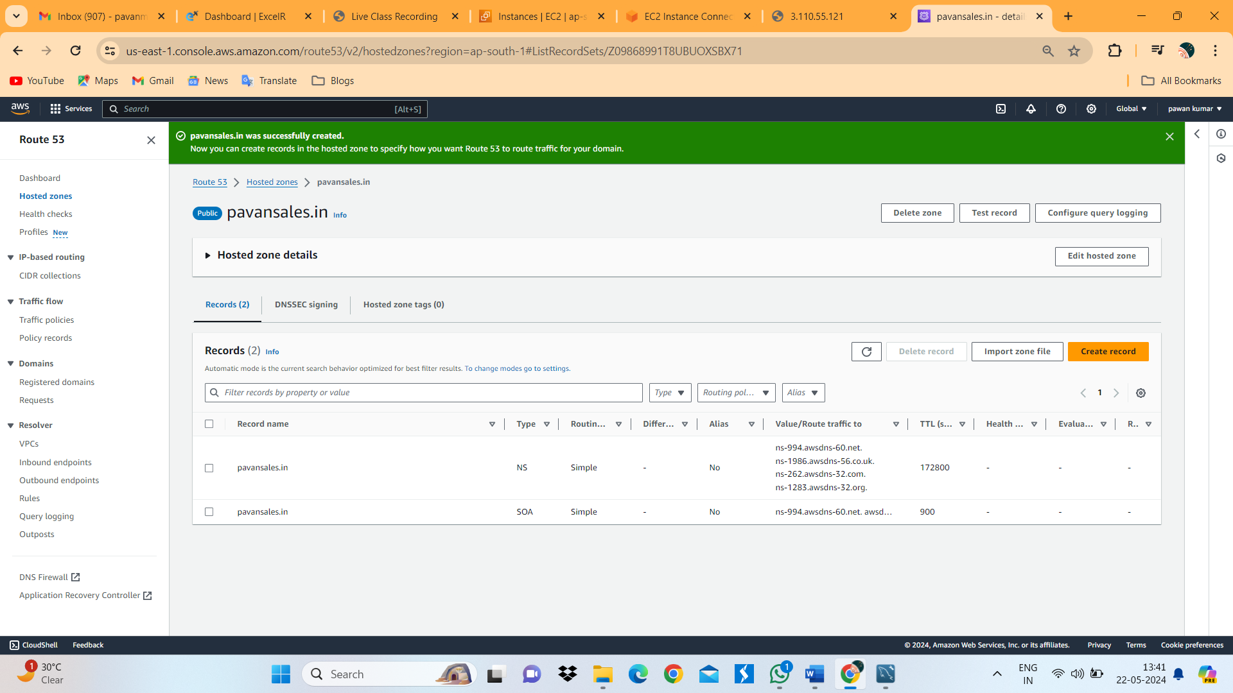

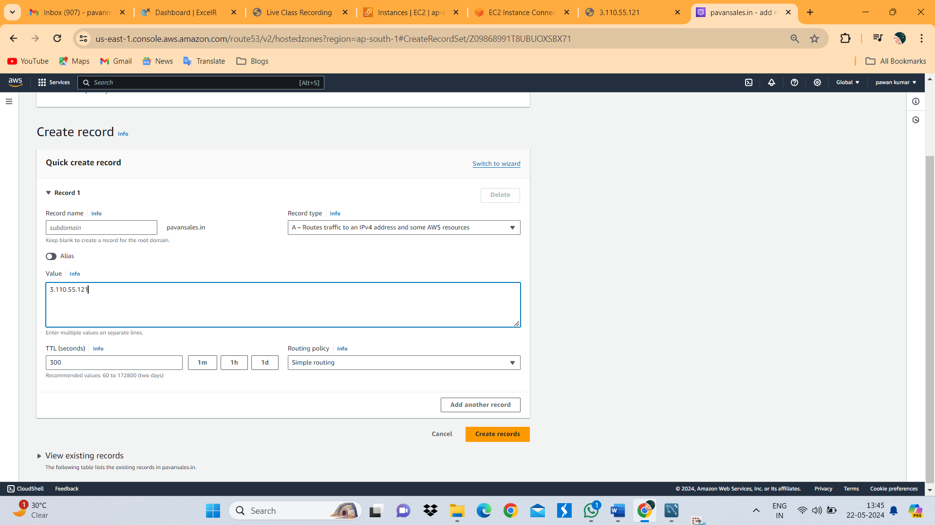

1. Select Record Type “A” and copy public IP in Values Section. And then click on create Record.
2. Checking Domain name is working or not. In below image.

